The Common Core for Rats?
—Dr. Ed Vavra

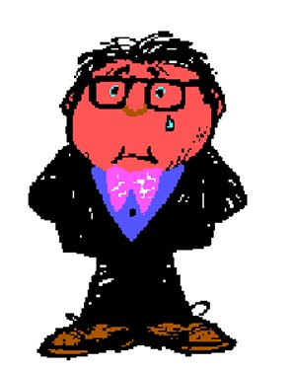
As an undergraduate, I had to take two science lab courses. For one of them, I chose psychology. In my ignorance, I thought I was going to be learning about Freud and Jung. Instead we studied Skinner. I spent sixteen weeks of three-hour labs training a rat! It was one of the most important courses I ever took. Stimulus-response conditioning is a very important concept, but my rat never had an understanding of what he (she?) was doing—or why. The Common Core treats our students as rats.
Check out the English Standards on the web: http://www.corestandards.org/ELA-Literacy/L/language-progressive-skills/. You’ll see that students are expected to “Do this,” or “Use that,” but there is very little, if anything, that students are expected to “know.” We’re told that there are many things that students should “understand,” but how they are to come to such an understanding is never made clear. My argument here is that knowledge of specific terms precedes “understanding.” Moreover, “knowledge” is easily testable; performance—“doing,” “using,” etc.—is very difficult to measure on an assessment test.
In teaching, specific terms are very important. In essence, they can denote schemas. In a previous letter I mentioned the book by Victor Benassi and others titled Applying Science of Learning in Education: Infusing Psychological Science into the Curriculum (2014) [Free at: http://teachpsych.org/ebooks/asle2014/index.php] It goes into great detail about the importance of schemas. Here, I’ll use the simple definition from Wikipedia: “a schema . . . describes an organized pattern of thought or behavior that organizes categories of information and the relationships among them.”
As Joyce Ehrlinger and E. Ashley Shain state in their article in Applying Science, “Effective learning requires metacognition—the process of reflecting upon which learning concepts one has already mastered, what still needs to be learned, and how to best approach the task of learning.” (142) In order to do that, however, we need to know the words that denote the various concepts.
How grammar is taught can illustrate the problem. Unfortunately, most instruction in grammar is still at the Grandgrind stage of memorizing unorganized, isolated facts—, for example, the parts of speech as word categories. Students are expected to memorize the definitions—and then not use them. A better approach is to treat these “parts” as functions.
Nouns, for example, can function as subjects, objects of verbs, and as objects of prepositions: “Sam hit the ball out of the field.” At an early stage in the study of grammar, students can be taught how to identify the nouns—and their functions—in most sentences that the students read and write. The result is a basic “schema” that can help students understand and organize more complicated grammatical constructions.
Perhaps most importantly, subordinate clauses can function in any way that nouns can: “[That Sam hit the ball out of the field] is not surprising.” I don’t have space for more examples, but the point is that we communicate many schemas by using specific terms. Students who understand and can identify the functions of nouns will have little trouble understanding noun clauses.
Similarly, they will have little trouble with verbals. A “verbal” is a verb that functions as a noun, adjective or adverb. For example, in the sentence “To win is not always the best goal,” the verbal “To win” has the noun function of subject. Currently textbooks do not get anywhere near explaining grammar as “an organized pattern of thought . . . that organizes categories of information and the relationships among them.” Then educators complain that students cannot apply what they have learned in one context in another.
The problem, I’m suggesting, is that the standards treat students like rats. The students are expected to “do,” “use,” “apply,” but they are given little understanding of the concepts that underlie (or should underlie) instruction.

Dr. Vavra has been teaching writing at the college level for almost forty years. He is also the developer of the free KISS Grammar site, a curriculum design and instructional materials that present clear objectives and standards. Additional open letters on the Core are available at KISSGrammar.org/Open_Letters. You may publish or share them in any way you like.

