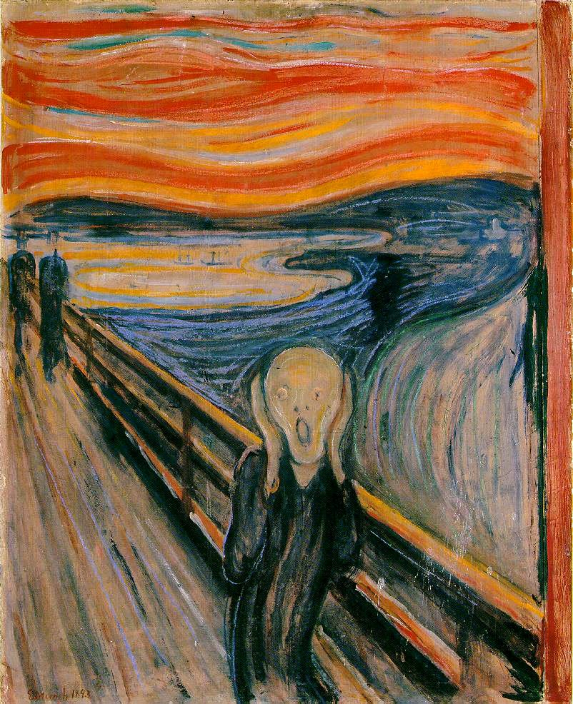  Edvard Munch’s The Scream  1893, National Gallery, Oslo | Major Paper # 3:  Summarizing  and  Analyzing  English 111 (Vavra)  Pennsylvania College  of Technology  January 8, 2010
Note: This assignment was for the Fall of 2010. I was informed that Golding’s “Thinking as a Hobby” is under copyright so I deleted it. I have, however, found at least one copy still on the web.

Instructions for Writing Summaries 1
Assignment 2
MP # 3 Checklist 3
Brainstorming 4
MP # 3 Summarizing and Analyzing - Grading Sheet(s) 6

Instructions for Writing Summaries
A summary is a short version of the major ideas in a book, chapter, article, etc. (An “abstract” is a shorter summary.) In college, you may be asked to write summaries to show that you have read assigned readings, or you may be required to write them as parts of longer papers. A summary must begin with the name of the author and the title of the work that is being summarized. Preferably, it also includes the major idea of the work: For example:

In Emotional Intelligence, Daniel Goldstein claims that emotions are as important for success as is brain-power.
or
According to Daniel Goldstein in Emotional Intelligence, emotions are as important for success as is brain-power.

If this information is missing, you have not written an acceptable summary.
As part of this assignment, you will be reading four somewhat difficult essays. You will be asked to read the essay, and write a summary of it before we discuss it in class. In these summaries, I expect you to begin with the proper information (otherwise, the homework will count for zero). I do not, however, expect you to get all the major ideas in the essays before we discuss them in class. I expect your summaries to demonstrate that you read the essays. In class, we will discuss them, and you should use your class notes to revise the summaries that you need for this paper.

Assignment
Write a 750 - 1250 word essay in which you summarize (and analyze) three of the four essays read and discussed in class on "thinking":
Mark Twain's "Corn-pone Opinions"
William Golding's "Thinking as a Hobby"
Plato's "Allegory of the Cave"
William G Perry's "Examsmanship and the Liberal Arts: A Study in Educational Epistemology"

Note: It is very easy to get a “C” in this assignment simply by reading the assigned works, writing a summary of each before the class discussion of it, taking notes during the class discussion, and then using those notes to revise your original summaries. Some of the essays are difficult to understand, but if you do the preceding, you will, in essence, be given everything that you need to get a relatively easy “C” for the paper.
If you want a grade better than a “C,” you will have to do more storming, thinking, and organizing on your own to analyze and compare the three essays.

Your introduction and thesis should reflect your conclusion about one major similarity in the thought of three of the writers. (Note that, for an “A” or “B,” you can not write about everything in the essays in the second part of your paper. The topic is too big.) Then, in a separate major section of the paper, you should explain that similarity (and the relevant differences) in the three writers’ ideas. Some students, for example, might focus on similarities and/or differences in the writers’ definitions of “thought.” On what would they agree? On what would they disagree? Are they talking about the same thing? Other students might want to focus on the thesis of each of the three writers -- what similarities and differences are there in the purpose of each writer? Other students might want to focus on one of the types of thinkers that the writers discuss. Each author divides thinkers or thinking into categories. In class, we will discuss these, but in your paper, you might want to focus on one of these categories and explain the similarities and differences in detail, including both their examples and your own. Other students might explore what the writers suggest about why people think in different ways. Other students might explore what each writer would say is the purpose of thinking. Some students might want to compare the nature of the examples that each writer uses and the implications of these examples. What do the examples have in common? How are they different? How do these similarities and differences relate to the major idea that each writer is interested in. Note that you cannot possibly write about all of the above. The topics are simply too complex. Your job is to narrow the topic and say something meaningful about your narrowed topic.

Audience: For this paper, you need not give me a publication. Assume that you are writing a paper for a course in education, philosophy, etc.

Thesis: For this paper, decide on your final thesis after you have written your conclusion. (You will probably be writing a draft of the second part of the paper as an in-class essay.) Take the key idea in your conclusion, and make it your thesis sentence. Then write the introduction to the paper. Don’t forget Graff’s “Who cares?” and “So what?”

Required Organization: Natural Division. For a “C,” you can organize this paper as a five paragraph essay:
I. Introduction and Thesis
II. [Name of the author of the essay summarized here.]
III. [Name of the author of the essay summarized here.]
IV. [Name of the author of the essay summarized here.]
V. Conclusion

For a grade better than “C,” you need to have subdivisions in your outline that will allow you to use a focal sentence in your essay. For example:
I. Introduction and Thesis
II. Summaries
A. [Author/Essay # 1]
B. [Author/Essay # 2]
C. [Author/Essay # 3]
III. [Your Narrowed Single Point of Interest]
A. Similarities [Establish that the three writers are comparable on this point.]
B. Differences [Explore the differences among the writers on this point.]
IV. Conclusion
Remember that the preceding is only an example of one way in which you can get subdivisions and that you will need to replace the words in brackets with your own ideas.

Details: In a summary, your details are actually the major relevant ideas in the works that you are summarizing. Thus your grades for details on the summaries will reflect how well you capture and present these. Take notes during the class discussions of the essays. Your grades for details on the analysis will depend on how clearly you can establish the similarities and differences in the writers’ ideas.

MP # 3 Checklist

In preparing your paper, do the following: (Suggestion: Read all the instructions before starting.)

_____ 1.) Complete the brainstorming sheets for this paper. (See below.)
_____ 2.) Make a tentative thesis and outline.
_____ 3.) Write a draft of the paper.
_____ 4.) Revise the draft at least once.
_____ 5.) Use the MLA format for your paper.
_____ 6.) Edit the draft.
_____ 7.) Print a double-spaced, final copy.
_____ 8.) If you have not already done so, make a paragraph outline.
_____ 9.) If you have not already done so, make an electronic copy of the paper and outline. Put all of these in one file, with the outline after the paper. Save it to a file with a name based on your last name, first initial, and the paper number. (For example, VavraEMP3.doc). Submit the electronic copy by (in order of preference) by
- copying it to the ENL111 folder in my S drive, or
- attaching it to an e-mail to me.
If the filename of the file you submit does not begin with your last name, I did not receive it.
_____10.) Put the finished copy, the grading sheet, the drafts, your outline, and all your notes into your envelope. (Mark the final copies so that they are identifiable.)

Brainstorming
Writing a good paper involves thinking your way into it. In essence, however, brainstorming is not a matter of simply "collecting" relevant details. Once you have them, to write a good paper you need to study them to see what they have in common, how they differ, etc. Thus, there are often different types (or stages) of storming. The brainstorming for this assignment should be based on your notes (both from your reading and from class discussion) on the articles you will write about. Some of these articles are very easy, and some are very difficult to understand. Begin, therefore, by reviewing your notes on each writer. (This will give you the material for your summaries.)
1. Each author creates at least two categories of "thinkers" and/or types of thinking. Make a separate storming sheet (or sheets) for each article. At the top of the page, put the author's name ("Golding," "Perry," "Plato" or "Twain") Divide the storming sheet into three roughly equal parts, labeled "a," "b," and "c." Then, for each writer, make notes for each of the following questions. (Note that your answers to these questions can give you excellent topic sentences for your summaries. They can also help you narrow your focus for the second, analytical part of the paper.)
a) How many categories does the author create? Use a word or phrase (the author's or your own) to distinguish each of the categories.
b) What are the characteristics of the thinkers or thinking in each of the author's categories? What key words or phrases can you quote from the article to describe each category? What are some of the specific examples that the author gives for each category?
c) What is this writer's overall view of "thinking" -- What does the writer suggest that "thinking" is? What is the purpose of "thinking?" What are its advantages and/or disadvantages? What can it do for us? Can one learn to think? If so, how?
2. After you have created a sheet (or sheets) for each writer, compare and contrast the writers' views. (This will give you the material for your analysis.) If at all possible, you need to establish a reason or reasons for comparing these specific essays. To do so, you need to find similarities in the writers' ideas. Begin by taking another sheet of paper. At the top of it, write "Similarities." Use it to make a table that will enable you to explore the similarities among the writers' categories. (See the table below.)
Obviously, Golding's "Grade Three Thinker" goes in "Category # 3," but the questions you want to address here are Is there a comparable category in Perry? Plato? Twain? If so, what similarities make them comparable? What about Category # 2? Category # 1? [Suggestion: If you want an “A” or “B” on this paper, do not use the table on this physical print-out -- you need more space in the table so that you can include the examples that each writer uses, brief explanations of each category, and other notes.]
3. After you have created the table in #2, select the three of the four writers that you want to discuss in your paper. Consider the similarities that you established in #2, and now look for differences. If Plato has a "Category 1" thinker, how does it differ from Golding's? At the top of still another sheet of paper, write "Differences," and make a table comparable to the one you made for similarities, but in this table you only need to explore three of the four writers. Complete this table by writing in words or phrases that distinguish one writer's thinkers from those of the other writers.
4. Finally, if you want an "A" or a "B," you should not write about more than one specific similarity among the three writers. Thus, for example, you might focus only on the similarities and differences in their views of what Golding calls Grade Two thinking. Once you have narrowed your focus, you might want to create your own examples to illustrate what you think each writer meant. You can use these examples to explain both the similarities and the differences in the analytical part of your paper. Then organize the similarities and differences you found for this specific idea to create subdivisions of the analytical part of the paper.
5. Make the thesis of your paper a statement about the idea(s) you arrived at in (4.)

 | Category # 1 | Category # 2 | Category # 3
Golding's?

Perry's?

Plato's?

Twain's?

Name:____________________________________

MP # 3 Summarizing and Analyzing - Grading Sheet(s)
You have the option of completing a set of detailed grading sheets for this paper. If you complete the entire set, your grades and the details of mine, plus additional comments will be returned to you on them. If you opt not to complete them, you will receive just this sheet with your grades. [If you do not hand in this sheet, you will receive just your grades.]

Summary of Grades for MP # 3
Process (40) |  | Product (60) | -
Paper Reflects Good Class Notes (5) |  | Audience (10)
Storming (5) |  | Thesis (10)
Outline (5) |  | Organization (10)
Paragraph Outline (5) |  | Details: (20)
Draft / Revision (5) |  | Style: (10)
MLA Format (5)
Correctly filed electronic copy (5) |  | Late Penalty (10 per day)
Everything in an envelope (5) |  | Style Penalty
 |  | Final Grade for Paper
Hostage [If anything is written in this box, see the section on "Additional Major Paper Requirements."

MP # 3 Audience (10 points)
Possible  Points | Student's  Grading | Instructor's  Grading | Description
0 - 1 |  |  | The title of the essay reflects thought.
0 - 2 |  |  | The essay reflects adequate and accurate storming, thereby making it worth the reader's time.
0 - 1 |  |  | The essay is not egocentric.
0 - 1 |  |  | The introductory paragraph is at least three sentences long - excluding the thesis statement.
0 - 2 |  |  | The introductory paragraph is—average (1) above average (2)—in interest and/or originality.
0 - 1 |  |  | The concluding paragraph does not refer to itself or to the essay (such as "In conclusion" or "In this essay.")
0 - 2 |  |  | The concluding paragraph is—average (1) above average (2)—in interest and/or originality.
-10 |  |  | Penalty for insulting many potential readers.

Name:____________________________________
Thesis (10 points)
Possible Points | Student's Grading | Instructor's Grading | Description
0 - 2 |  |  | The thesis is clearly identifiable.
0 - 3 |  |  | The thesis reflects thought about the assignment.
0 - 1 |  |  | The main grammatical subject of the thesis sentence is the topic of the essay, not the writer or the essay itself.
0 - 1 |  |  | The thesis covers the topics discussed in the essay.
0 - 3 |  |  | The paper goes beyond simple summaries.

Organization (10 points)
NB: This essay must be organized in "natural divisions" with a minimum of five paragraphs; otherwise it will receive NO credit for organization.
Possible  Points | Student's  Grading | Instructor's  Grading | Description
0 - 1 |  |  | The formal outline is well organized to support the thesis.
0 - 1 |  |  | Topic sentences embody the outline.
0 - 1 |  |  | Topic sentences clearly reflect the relationship of paragraphs to the thesis.
0 - 1 |  |  | Paragraphs develop & organize distinct ideas or sub-topics.
0 - 1 |  |  | Paragraphs are neither too long nor too short.
0 - 3 |  |  | Focal Sentence - Sub-divisions of a major section of the outline (Roman number) are spread over more than one paragraph.
0 - 1 |  |  | First Topic Sentence of Sub-division
0 - 1 |  |  | A Second Topic Sentence of Sub-division

MP # 3 Details (20 points)
Fill in the blanks with the name of the author of the relevant source.
Possible  Points | Student's  Grading | Instructor's  Grading | Description
0 - 4 |  |  | The summary of ___________________ is well done.
0 - 4 |  |  | The summary of ___________________ is well done.
0 - 4 |  |  | The summary of ___________________ is well done.
0 - 4 |  |  | The paper explains one basic similarity in the writers' ideas.
0 - 4 |  |  | The paper explores differences in that similarity.

Style (10 points)
Possible Points | Student's Grading | Instructor's Grading | Description
0 - 2 |  |  | Quotation marks, underlining, and italics are used correctly.
0 - 2 |  |  | First person is not used.
0 - 1 |  |  | Verb forms and tenses are used correctly.
0 - 1 |  |  | There are no (few) usage problems.
0 - 3 |  |  | Transitional words and phrases are well used.
0 - 1 |  |  | There are no careless (sloppy) errors.

